Field Hockey: Review

1. What do other countries call Field Hockey__________________________________ (1pt)

2. Play the __________________ - not the _______________________ . (1pt)

3. List the 3 types of dribbling techniques in Field Hockey that we learned and discussed in class. Describe each one. (4pts. each)

1.

2.

3.

4. Basic Rules: Please tell me 4 BASIC RULES of Field Hockey that were discussed in class/given to you on the FH Handout. (2pts each)

1.

2.

3.

4.
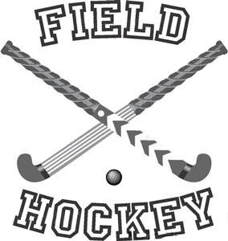

5. Read the following:

Field hockey was originally considered too dangerous a sport for female participants. This notion later changed when women who enjoyed outdoor activities, such as croquette and lawn tennis, adopted field hockey as a socially acceptable outdoor activity. It was later considered as the only team sport proper for women. Over the years, females have competed against the stereotype of being too fragile to play strenuous sports. Often being told they cannot do something, being bullied for wanting to participate in a certain activity, and even successful athletes, instead of being recognized for their success were often criticized. The reason women’s athletics have come so far is because these women showed how much they cared, and didn’t give up because it was something they were passionate about.

Read more at: http://fieldhockey.isport.com/fieldhockey-guides/history-of-field-hockey

Tell me something that you’re passionate about, whether is be drawing, reading, playing soccer, football, tennis, horseback riding, bicycle riding, skiing, skateboarding, etc. EXPLAIN to me why this activity is such an important part of your life. What does participating in the activity mean to you (think about how you would feel if it was taken away from you). Explain the feeling you get from participating in the activity.

Please use complete, thoughtful sentences, descriptive language, examples, and reasons.

