Frisbee Basics: Name: ______________________________ Class:____

- Using the Frisbees below, illustrate and label three ways to catch a Frisbee (6pt.):

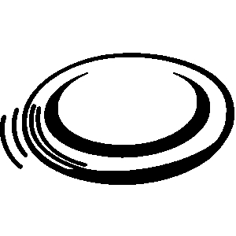

- Describe how to throw a Frisbee using the cues discussed in class (6pt.)
Answer:
Eyes looking
Shoulder to target
Frisbee is curled into your belly
Step towards your target
Extend throwing arm
Flick wrist
Follow through to target

Frisbee Basics: Name: ______________________________ Class:____

- Using the Frisbees below, illustrate and label three ways to catch a Frisbee (6pt.):

- Describe how to throw a Frisbee using the cues discussed in class (6pt.)

- Please give an example for the following:
I want to throw the Frisbee to my friend Tia, how do I get her attention? (2pt.)

I want the Frisbee. What should I say and what should I do with my body? (2pt.)

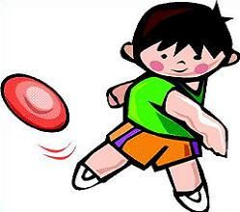

- Please give an example for the following:
I want to throw the Frisbee to my friend Tia, how do I get her attention? (2pt.)

I want the Frisbee. What should I say and what should I do with my body? (2pt.)

