P.E. PICKLEBALL CHAMPIONS
2016
Congratulations,

03/03/16 __________________________________
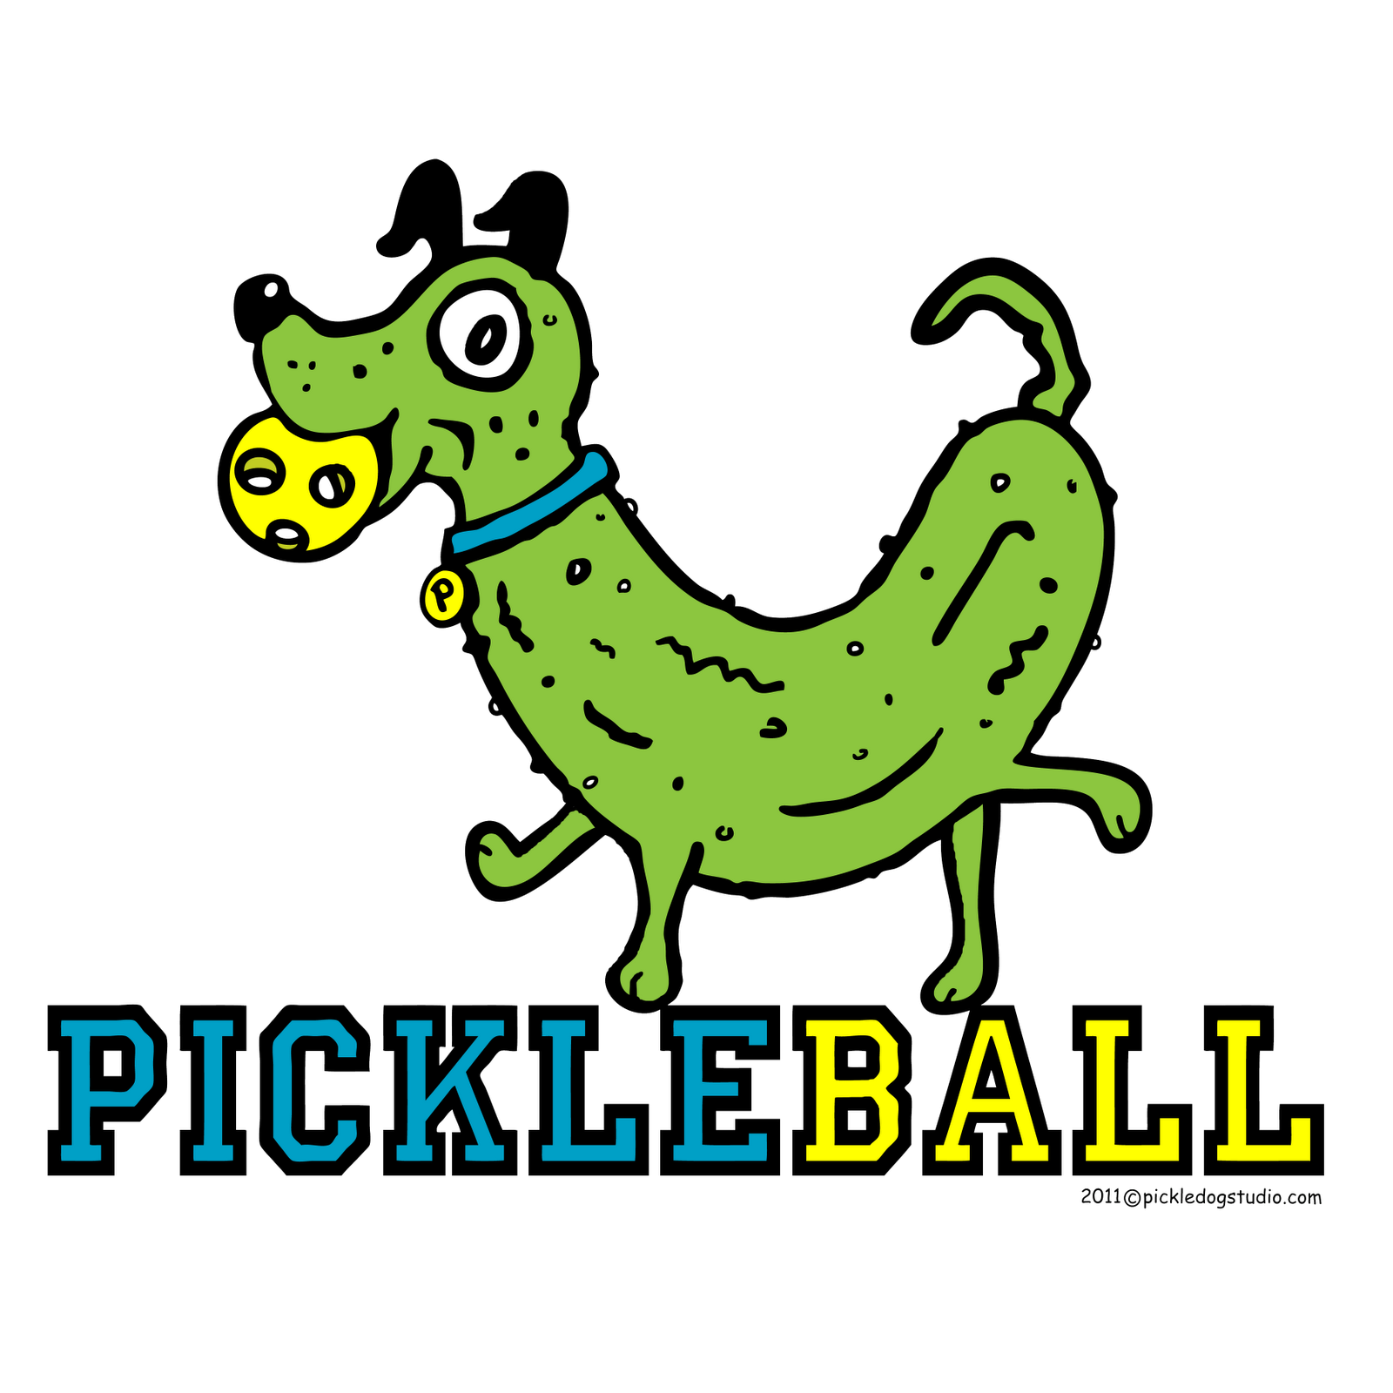

P.E. PICKLEBALL CHAMPIONS
2016
Congratulations,

03/03/16 __________________________________

PICKLEBALL RUNNER-UPS
2016
Congratulations,

03/03/16 __________________________________

PICKLEBALL RUNNER-UPS
2016
Congratulations,

03/03/16 __________________________________

